AI VIRTUAL TRY-ON
(Web Based Application)

A PROJECT REPORT
ON

AI VIRTUAL TRY-ON

SUBMITTED BY
ANUJ YADAV AND PINKU THAKUR

UNDER THE GUIDENCE OF
PROFESSOR: NIYATI KALYANPUR

EXAMINATION BSC.IT, SEMESTER


UNIVERSITY OF MUMBAI
DEPARTMENT OF INFORMATION TECHNOLOGY

GHANSHYAMDAS SARAF COLLEGE OF ARTS AND COMMERCE
(Affiliated to university of Mumbai) MUMBAI 400064 MAHARASHTRA
2025-2026

AI VIRTUAL TRY-ON

A Project Report
Submitted in partial fulfillment of the Requirements for the award of the Degree of

BACHELOR OF SCIENCE (INFORMATION TECHNOLOGY)

By

Anuj Yadav and Pinku Thakur
Roll No. 59 and 51

Under the esteemed guidance of
Prof. Niyati Kalyanpur


DEPARTMENT OF INFORMATION TECHNOLOGY

GHANSHYAMDAS SARAF COLLEGE OF ARTS AND COMMERCE
(Affiliated to university of Mumbai) MUMBAI 400064 MAHARASHTRA
2025-2026

DEPARTMENT OF INFORMATION TECHNOLOGY GHANSHYAMDAS SARAF COLLEGE OF ARTS AND COMMERCE
(Affiliated to university of Mumbai)



CERTIFICATE

This is to certify that the project entitled, "AI Virtual Try-on ", is bonafied work of Anuj Yadav bearing Seat No: (59) and Pinku Thakur bearing Seat No: (51) submitted in partial fulfilment of the requirements for the award of degree of BACHELOR OF SCIENCE in INFORMATION TECHNOLOGY from University of Mumbai.

Internal Guide Coordinator

External Examiner

Date: College Seal

ABSTRACT

The AI Virtual Try-On System for Men is designed to act as a digital fashion assistant, helping users visualize how clothing and accessories would look on them before making a purchase. The concept of this system is simple yet powerful: users can upload their photo or use a webcam, select clothing items and accessories, and instantly preview a realistic try-on image. The application also provides features such as AI-based outfit recommendations, digital wardrobe management, full outfit simulations, and the ability to save, download, or retry looks. Unlike existing virtual try-on solutions that are limited to clothing only or lack realism, this system incorporates accessories such as glasses, watches, and shoes, offering a more complete styling experience. Furthermore, the project integrates an AI recommendation engine to suggest the best outfit combinations based on user preferences and occasions. With its combination of practicality, innovation, and user-friendliness, this project aims to enhance the online shopping and styling experience by reducing uncertainty, saving time, and increasing user confidence in their fashion choices.

ACKNOWLEDGEMENT

We take this opportunity to express our profound gratitude and indebtedness to our project guides Prof.
Niyati Kalyanpur for giving us the opportunity to accomplish this project.

We are very much thankful to Prof. Niyati Kalyanpur for being very much resourceful, kind and helpful. Her positive attitude, unassailable optimism and unawaring faith in us assured that we came out of problems whenever we encountered difficulties.

Finally we wish to thank all my friends and IT department to directly or indirectly helped us in the completion of this project. Last but not the least we would thank our family without whose support, motivation and encouragement this would not have been possible.

DECLARATION

We hereby declare that the project entitled, “AI VIRTUAL TRY-ON” done at Malad, has not been in any case duplicated to submit to any other university for the award of any degree. To the best of our knowledge other than us, no one has submitted to any other university.
The project is done in partial fulfillment of the requirements for the award of degree of BACHELOR OF SCIENCE (INFORMATION TECHNOLOGY) to be submitted as final semester project as part of our curriculum.

Anuj Yadav

Pinku Thakur

TABLE OF CONTENTS

CHAPTER 1 4
INTRODUCTION 4
  - Background 4
  - Objective 4
  - Purpose and Scope 4
    - Purpose 4
    - Scope 5
  - Applicability 5
  - Organisation of Report 5
CHAPTER 2 6
SURVEY OF TECHNOLOGY 6
  - Software 6
  - Back End Technologies 9
  - Languages 11
CHAPTER 3 14
REQUIREMENT AND ANALYSIS 14
  - Problem Definition 14
  - Requirement Specification 14
    - Non-Functional Requirement 14
    - Functional Requirement 15
  - Planning and Scheduling 15
  - Software and Hardware Requirement 17
    - Software Requirement 17
    - Hardware Requirement 17
  - Preliminary Description 18
  - Conceptual Models 18
    - Data Flow Diagram 19
    - Use Case Diagram 20
    - Activity Diagram 21
    - Sequence Diagram 26
    - Class Diagram 27
    - Entity Relationship Diagram 28
    - Event Table 29
CHAPTER 4 30
SYSTEM DESIGN 30
  - Basic Modules 30
  - Data Design 31
    - Schema Design 31
    - Data Integrity 32
  - Procedure Design 33
    - Flow Chart 33
  - Algorithm Design 34
  - UI Design 36
  - Test Case Design 37

LIST OF TABLES

Table 3.6.7 1: Event Table 29
Table 4.2.2 1: User Table 32
Table 4.2.2 2: Emergency_Contacts 32
Table 4.2.2 3: Location 32
Table 4.2.2 4: Helpline_Number 32
Table 4.6 1: Test Case Design 38
Table 5.3.1 1 Login.Java 48
Table 5.3.1 2 Register1.Java 49
Table 5.3.1 3 Register2.Java 50
Table 5.3.1 4 Forgot.Java 51
Table 5.3.1 5 Forgot_Next.Java 51
Table 5.3.1 6 Edit_Details.Java 52
Table 5.3.1 7 Add_Emergency_Contacts.Java 52
Table 5.3.1 8 Add_Location.Java 53
Table 5.3.2 1 Integration Testing 55
Table 6.1.2 1 Summary Of Unit Testing 57
Table 6.1.2 2 Summary Of Integration Testing 58

LIST OF FIGURES

Fig 3.3 1 : Gantt Chart 16
Fig 3.3 2: Pert Chart 16
Fig 3.6.1 1: Data Flow Diagram 19
Fig 3.6.2 1: Use Case Diagram 20
Fig 3.6.3 1: Activity Diagram 24
Fig 3.6.4 1: Sequence Diagram 26
Fig 3.6.5 1: Class Diagram 27
Fig 3.6.6 1: Entity Relation Diagram 28
Fig 4.2.1 1: Schema Design 31
Fig 4.5 1: UI Design 36

CHAPTER 1
INTRODUCTION
1.1 Background
In today’s digital-first world, fashion e-commerce continues to grow rapidly, but a major drawback still exists — customers are unable to try on clothes or accessories before making a purchase. This results in uncertainty, hesitation, and high return rates. The AI-Powered Virtual Try-On System for Men is built to eliminate these issues by offering a unique platform where users can virtually try on outfits, accessories, and even shoes in a realistic manner.
This system not only overlays items on user images or webcam feed but also offers an advanced AI-Generated Virtual Try-On feature, which creates photorealistic images of the user wearing the selected clothes/accessories. Users can also save their outfit combinations into a Digital Wardrobe, retry saved looks, delete them, or filter based on style, date, or accessories.
The platform includes a Best Outfit Combination Engine and AI Recommendation System that intelligently suggest clothing combinations based on body type, personal preference, and occasion. Additionally, the app can detect user location (e.g., college, office, or home) and adjust the user's fashion profile or recommendations accordingly. This smart and interactive system redefines how men shop for fashion, plan outfits, and visualize styles using cutting-edge technology.

1.2 Objective
Facilitate Virtual Try-On: Enable users to virtually try on men’s fashion items, including clothes, accessories, and shoes, by utilizing uploaded images or live webcam feeds.
Generate Realistic Visualizations: Produce AI-based, photorealistic images of the user wearing selected outfits, thereby boosting confidence in fashion choices.
Manage Digital Wardrobe: Provide robust functionality for saving, organizing, and managing outfit combinations within a feature-rich Digital Wardrobe.
Deliver AI-Powered Recommendations: Offer intelligent suggestions for clothing and accessories, personalized based on user preferences, body shape, and intended purpose.
Suggest Optimal Combinations: Automatically propose the best outfit combinations through smart matching logic derived from fashion principles.
Ensure User-Friendly Interface: Develop a web-based and mobile-friendly interface characterized by intuitive design and seamless drag-and-drop functionality.
Provide Live Interactive Experience: Deliver a smooth and realistic live try-on experience, allowing users to interactively drag and drop clothing and accessories in webcam mode.
Implement Location-Based Personalization: Integrate location detection to enable automatic profile switching, adjusting recommendations and preferences based on the user's environment (e.g., college, gym, home).
Ensure Secure Data Management: Utilize Firebase integration for secure user authentication and reliable cloud-based storage of outfit data.

1.3 Purpose & Scope
Purpose:
The AI Virtual Try-On for Men is more than just a tool; it's a gateway to self-expression and confidence. We believe that every man deserves to feel empowered and assured in his style choices, without the frustration of guesswork or the disappointment of ill-fitting purchases. In a world increasingly shaped by digital experiences, the emotional connection to fashion often gets lost. This platform is designed to reignite that spark, offering a truly immersive and visually engaging journey where men can explore, experiment, and truly see themselves in their desired looks. The unique ability to generate AI-enhanced, photorealistic try-on images doesn't just reduce returns; it builds a profound sense of certainty and excitement, transforming the anxiety of online shopping into a joyful exploration of personal style. Our ultimate goal is to liberate men from fashion doubts, allowing them to visualize, compare, save, and share their favorite looks with unparalleled ease, unwavering confidence, and genuine excitement.

Scope:
The system focuses entirely on men’s fashion and accessories and will support the following features:
❏ AI-Powered Virtual Try-On: Upload a photo or use a webcam to try clothes and accessories virtually.
❏ Realistic Image Generator: Automatically generate realistic images showing the user in full outfits using AI.
❏ Digital Wardrobe: Save, view, delete, or filter outfit combinations for future use.
❏ AI Recommendation System: Suggest items based on body structure, preferences, weather, occasion, and saved history.
❏ Best Outfit Combo Engine: Auto-generate the best fashion combinations using backend intelligence.
❏ Live Webcam Mode: Drag and drop accessories or garments live with the camera on.
❏ GPS Location Detection: Change fashion profiles based on location (college, gym, workplace).
❏ Firebase Integration: Secure login, image storage, and wardrobe backup using Firebase Authentication, Firestore, and Storage.
❏ Responsive UI: Designed to work across devices with smooth transitions and attractive interface.

1.4 Applicability
This virtual try-on platform can benefit various categories of users and industries:
❏ Online Shoppers: Helps visualize and finalize choices before placing an order.
❏ Retailers & Brands: Can integrate this system into their websites to reduce return rates and boost engagement.
❏ Stylists & Influencers: Use the realistic simulation to create looks for clients or followers.
❏ Fashion Enthusiasts: Organize their wardrobe, try new styles, and save multiple outfit ideas.
❏ Students & Working Professionals: Plan appropriate looks for different environments like college, office, or events.
❏ Health-Conscious or Physique-Focused Users: Choose styles that suit their body type using AI analysis.
❏ Tech Startups: Can further build on this platform for AR/VR-based fashion or multi-gender clothing apps in the future.
The AI Virtual Try-On app brings innovation to everyday styling needs with automation, customization, and realism, changing how men interact with fashion.
1.5 Organization of Report perfect
The subsequent chapters of the project report will focus on the survey of different technologies which includes comparison of different platforms, languages, software, hardware etc. The Survey if followed by the analysis of requirements resulting in generation of requirement specification and schedule of activities. It also includes the conceptual design that visualizes the features and operations that can be performed on the system. The final chapter of the project report includes the system design that describes desired features and operations in detail, including screen layouts, business rules, process diagrams, pseudo code and other documentation.

Chapter 2: System Analysis

2.1 Software
The AI Virtual Try-On for Men is an advanced web-based application that integrates artificial intelligence, image processing, and cloud technologies. The system requires a combination of software tools and services to enable a seamless virtual try-on experience for users. The software selection is based on the core requirements of the system such as real-time rendering, user authentication, secure storage, and the ability to process AI-based image transformation. Below is the list of software used:
· Visual Studio Code – Chosen as the primary code editor due to its powerful extensions, debugging features, and seamless integration with web development technologies.
· Google Chrome / Mozilla Firefox – Used for testing and debugging the user interface, webcam access, and responsive design.
· Firebase (Authentication, Firestore) – Acts as the backend of the application, providing real-time database capabilities and user management.
· AWS S3 + SQL Database – Planned for use as a custom solution to store user-generated outfit images and metadata. This will allow more control, scalability, and flexibility in managing storage and database operations.
· Google Colab – A free cloud-based environment used to run the StableVITON or VITON-HD AI model for realistic virtual try-on processing.
· Flask (Optional) – A Python-based lightweight framework considered for creating APIs that connect the frontend with the AI model running on Google Colab.
· HTML, CSS, JavaScript – Core technologies used for frontend development and interaction handling.
These software tools were chosen after careful evaluation based on ease of integration, learning curve, performance, cost-effectiveness, and community support.

2.2 Front-End Technologies (Comparative Study & Selection Reason)
The front end is the part of the system that interacts directly with the user. Since the application is web-based and needs to be responsive, interactive, and visually engaging, careful selection of front-end technologies was critical. The selected technologies and the reasons behind not choosing other popular options are explained below.
Technology | Description | Pros | Cons | Selected/Not Selected (Why)
HTML5 | Standard language to structure web content | Simple, widely supported, essential for any webpage | Cannot perform logical operations | ✅ Required for building the structure of the web app
CSS3 | Styling language for HTML | Enables responsive design, animations | Complex layouts may need more code | ✅ For creating appealing, mobile-friendly UI
JavaScript | Programming language for frontend logic | Interactive UI, access to webcam, dynamic elements | Needs careful coding to avoid errors | ✅ Required for all interactivity and logic
React.js | JavaScript UI library | Component-based, efficient updates | Complex for beginners, adds build setup overhead | ❌ Not used – Project is built without React
Bootstrap | CSS Framework | Fast prototyping, responsive grid | Limited customization, can look generic | ❌ Not used – Custom CSS styling preferred for flexibility
Conclusion: The chosen technologies – HTML, CSS, and JavaScript – provide a clean, customizable, and flexible foundation for the virtual try-on interface. Technologies like React.js and Bootstrap were considered but not used to keep the project lightweight, fully customizable, and beginner-friendly.

  - Back-End Technologies (Comparative Study & Selection Reason)

The backend of the AI Virtual Try-On system handles user authentication, image and outfit data storage, and optional API services to connect the AI model. Considering real-time requirements and budget constraints (free tier usage), multiple backend technologies were evaluated:

Technology | Description | Pros | Cons | Why Selected
Firebase | Google cloud backend (Auth, DB) | Easy setup, real-time sync, free Spark plan | Limited storage and bandwidth in free plan | ✅ Selected for user login and temporary data management
AWS S3 + SQL | Custom storage and database solution | High flexibility, scalable, full control over data | Requires configuration, hosting, and access management | ✅ Planned to store rendered outfit images and metadata permanently
Node.js + Express | JavaScript-based backend server | Scalable, flexible APIs | Requires own server/hosting, setup complexity | ❌ Not selected – unnecessary complexity for current scope
Flask | Python web framework | Simple to create API endpoints | Needs deployment, server, and security setup | ✅ Used optionally for API to run AI model from frontend
MongoDB | NoSQL database | Schema-less, good for large datasets | Needs third-party hosting | ❌ Not selected – SQL is preferred for structured outfit data
Django | Full-featured Python framework | Scalable, includes admin panel | Overkill for simple API | ❌ Not selected
Conclusion: Firebase is used for quick integration and prototyping, while AWS S3 and SQL will serve as the permanent storage and database solution. This approach ensures cost efficiency during development and long-term scalability in production.

2.4 Languages (Comparative Study & Selection Reason)
Languages used in the project play a significant role in determining the scalability, maintainability, and functionality of the system. The following table compares different programming languages considered for various components of the project:

Language | Area Used | Pros | Cons | Why Selected
HTML | Frontend structure | Essential, easy to use | Cannot perform logic | ✅ Required to build the webpage structure
CSS | Styling the UI | Custom designs, responsive layout | Purely visual, not logical | ✅ Used for responsive and appealing frontend
JavaScript | Frontend logic, webcam access, overlays | Rich interactivity, DOM access, async operations | Can become complex, needs testing | ✅ Required for core interactivity and dynamic UI
Python | AI model, backend API (via Flask) | Perfect for AI, easy syntax, supported by Google Colab | Not used directly in browser | ✅ Used in Colab to run StableVITON/VITON-HD
SQL | Backend database for storing outfit metadata | Structured queries, relational design, efficient lookup | Requires schema design and setup | ✅ Planned for storing metadata and query-based access
PHP | Server-side scripting | Common for web backends | Less relevant for AI and modern JS frameworks | ❌ Not selected
Java | General-purpose backend or Android apps | Robust, scalable | Verbose, not ideal for web projects | ❌ Not selected

Conclusion: The combination of HTML, CSS, JavaScript, Python, and SQL provides a balanced, powerful, and efficient programming stack. JavaScript drives all frontend functionality, while Python powers the AI processing. SQL and AWS S3 together will ensure a reliable and scalable backend infrastructure.

Overall Summary:
The technologies chosen for this project aim to strike a balance between simplicity, performance, and integration capabilities. With HTML, CSS, and JavaScript handling the user interface and interactivity, Firebase managing authentication, AWS S3 storing images, SQL storing metadata, and Python operating the AI engine, the system offers a smooth and intelligent user experience. Technologies like React.js and Bootstrap were deliberately excluded to keep the project lightweight and fully customizable. The decisions were made based on compatibility, ease of learning, and support for advanced features like real-time image overlays and AI-based clothing simulation.

Chapter 3: REQUIREMENT AND ANALYSIS

3.1 Problem Definition
In the era of e-commerce and online shopping, men often struggle to visualize how clothes, accessories, or complete outfits will look on them before purchase. Traditional product images provide only limited perspective, leading to uncertainty and frequent return requests.
Scenarios customers don’t like:
- Clothing shown online does not look the same when worn.
- No real-time try-on experience.
- Difficulty in mixing and matching outfits.
- Inability to test accessories (like watches, glasses, earrings) with clothes.
- No personalized recommendations based on body type and style preferences.
Whereas, our project AI Virtual Try-On for Men overcomes all these limitations by:
- Providing realistic try-on simulations using AI models.
- Supporting both static image upload and real-time webcam try-on.
- Offering a digital wardrobe where users can save, re-try, and delete outfits.
- Delivering AI-powered outfit recommendations and best combination suggestions.
- Ensuring smooth account management and login system via Firebase.
Thus, the project enhances men’s online shopping experience with a personalized, real-time, and engaging virtual fitting room.

3.2 Requirement Specification
3.2.1 Functional Requirements
✓ Application must allow users to upload personal images or use the webcam for live try-on.
✓ Clothes, shoes, and accessories should be overlaid in real-time with proper adjustment (scaling, dragging).
✓ A digital wardrobe must store saved outfits (with metadata: style, date, accessories).
✓ Users should be able to delete, filter, and re-try saved outfits.
✓ An AI Recommendation System suggests outfits based on body type, event, or previous choices.
✓ A Best Outfit Combination Engine auto-selects matching clothing + accessories.
✓ Users must be able to download their try-on result as an image.
✓ The app should support Firebase authentication (Login/Signup).
✓ Saved outfits must be synced in Firebase Firestore + Storage.
✓ Responsive UI for both desktop and mobile devices.

3.2.2 Non-Functional Requirements
✓ Attractive and modern user interface (full screen, responsive, mobile-friendly).
✓ Fast processing of uploaded images and outfit rendering.
✓ Real-time rendering without lag, even with multiple accessories.
✓ Cloud database must be scalable to handle many users and outfits.
✓ Smooth switching between Wi-Fi and mobile data without breaking functionality.
✓ Secure handling of user images and stored wardrobe data.
✓ Easy-to-use UI (no manuals required for navigation).
✓ Loading overlay during login/signup/try-on for better user experience.

3.3 Planning and Scheduling
Number of Personnel: 2
Estimated Start Date: 1st July, 2025
Estimated End Date: 28th February, 2026
3.3.1 Task Schedule Planning

Task Name | Duration | Start Date | End Date
Selecting the Project | 31 Days | 01-07-2025 | 31-07-2025
Gathering of requirement | 45 Days | 01-08-2025 | 14-09-2025
Requirement Analysis | 15 Days | 15-09-2025 | 30-09-2025
System Analysis | 31 Days | 01-10-2025 | 31-10-2025
Designing | 30 Days | 01-11-2025 | 30-11-2025
Documentation | 26 Days | 15-11-2025 | 10-12-2025
Coding / Implementation | 46 Days | 01-12-2025 | 15-01-2025
Testing (Unit + Integration) | 30 Days | 16-01-2026 | 14-02-2026
Deployment | 14 Days | 15-02-2026 | 28-02-2026

3.3.2 Gantt Chart
A Gantt chart will be used to show project phases with time duration, covering requirement analysis → design → implementation → testing → presentation.

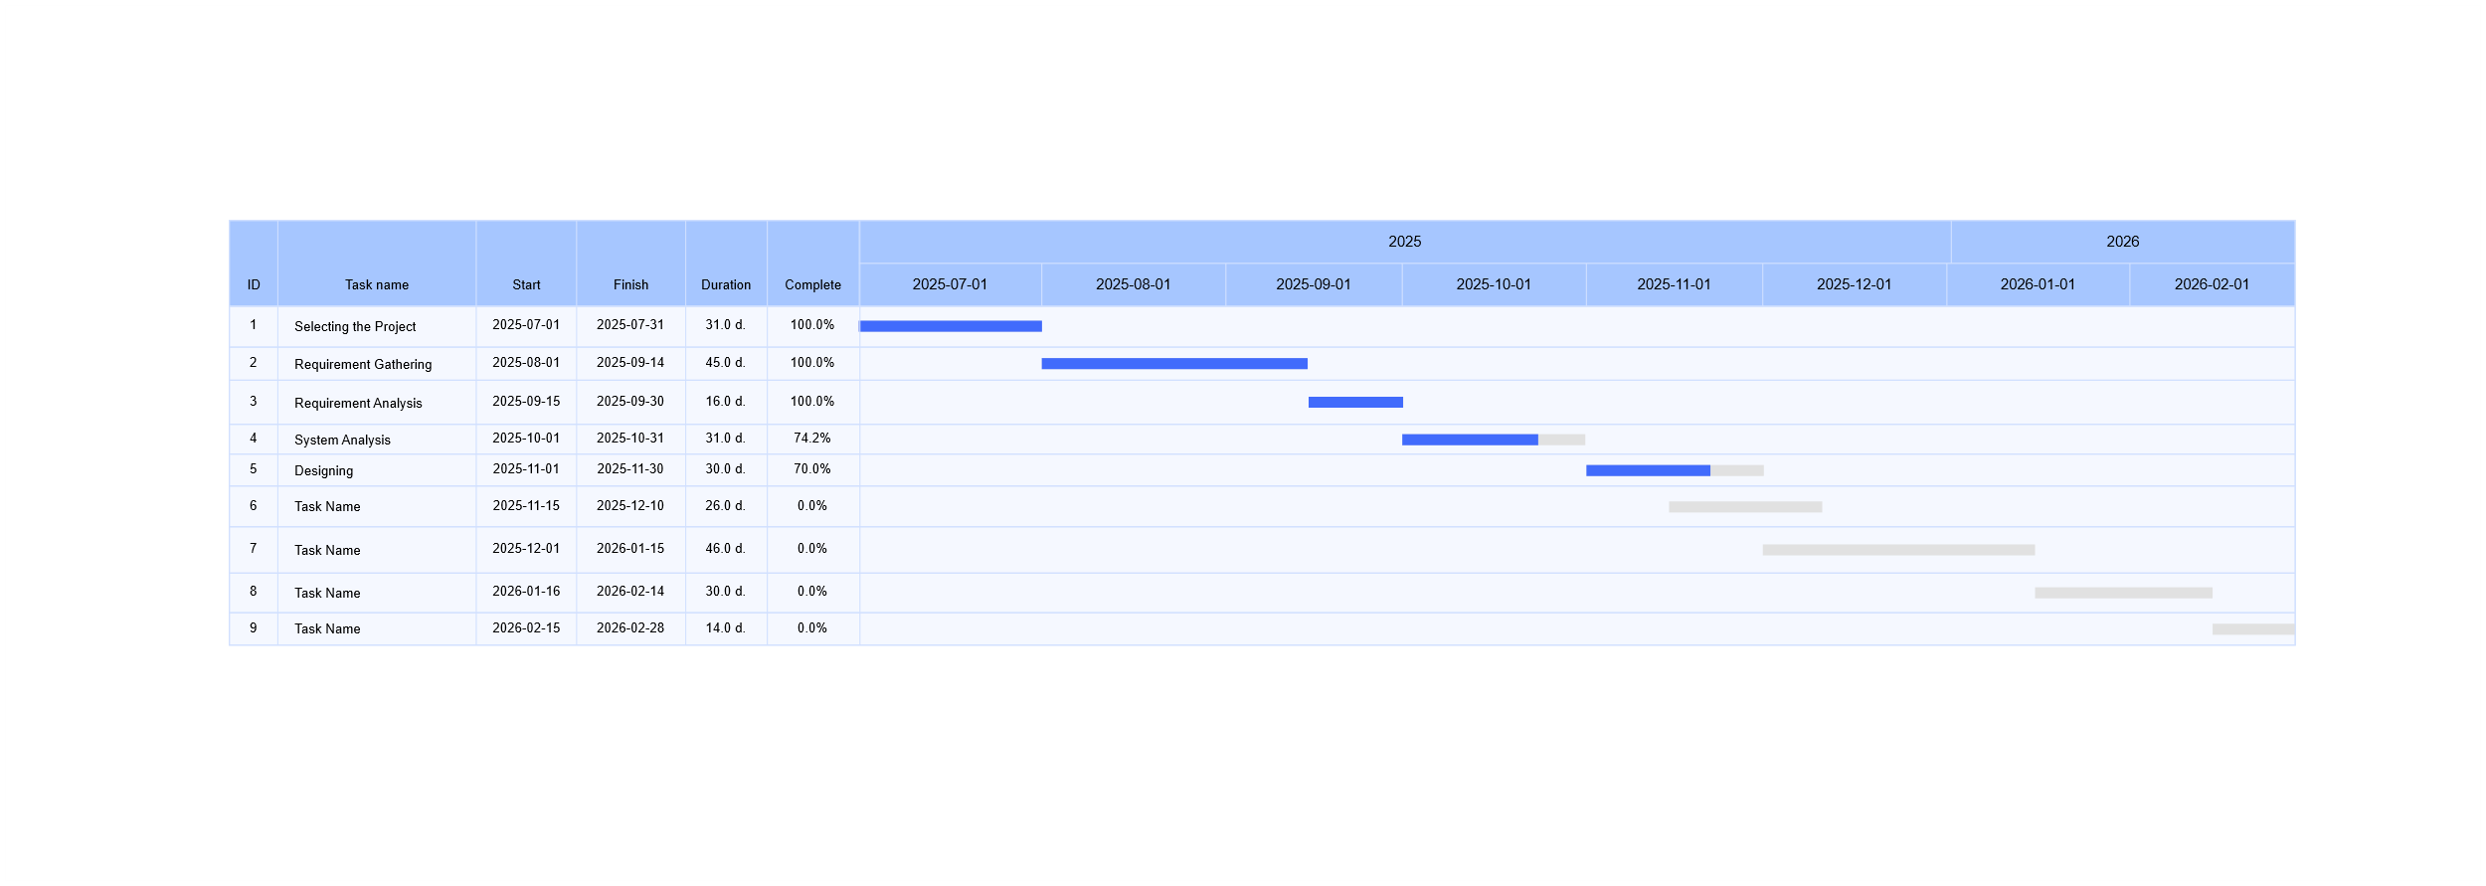

3.3.3 PERT Chart
A PERT Chart will be used to identify dependencies among tasks such as:
- Requirement Gathering → Requirement Analysis → System Analysis.
- Design → Coding → Testing → Deployment.
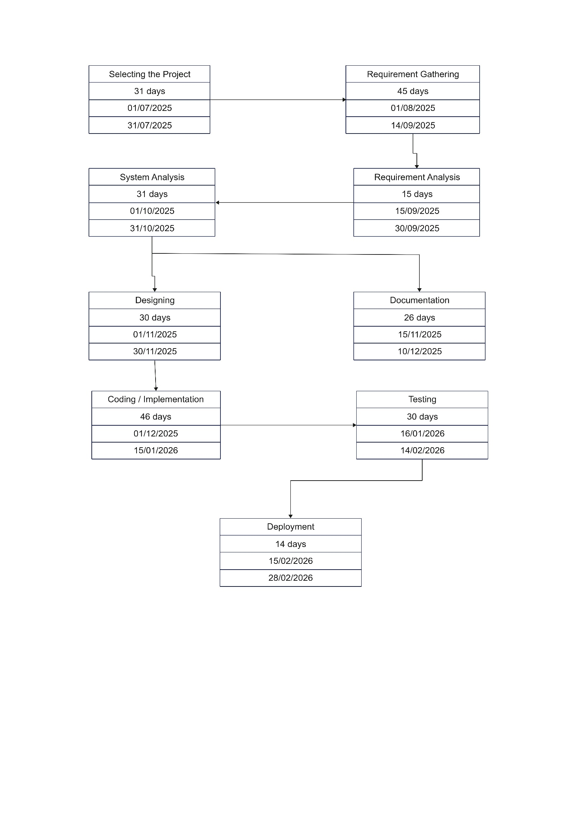

3.4 Software and Hardware Requirements
3.4.1 Software Requirements
For Development:
Operating System: Windows 10/11 (64-bit) / Google Colab (Linux)
Software: VS Code, Firebase Console, Google Colab (for AI model)
Languages: HTML, CSS, JavaScript (Frontend), Python (Backend/AI Model)
Frameworks & Tools: Flask/Gradio (API), Firebase SDK, OpenCV, PyTorch, StableVITON
Database: Firebase Firestore + Firebase Storage
For Running on Device:
Any modern browser (Chrome/Edge/Firefox)
Android / iOS support via mobile browser

3.4.2 Hardware Requirements
For Development:
- PC with at least 8 GB RAM (16 GB recommended)
- GPU Support (NVIDIA CUDA) preferred, else Google Colab GPU
- Disk space: 10 GB (for datasets, models, and project files)
Other Hardware Components:
- Webcam (for live try-on feature)
For Running on Device:
- Smartphone / Laptop with camera access
- Internet connection for Firebase & AI API
3.5 Conceptual Model

3.5.1 Data flow diagram
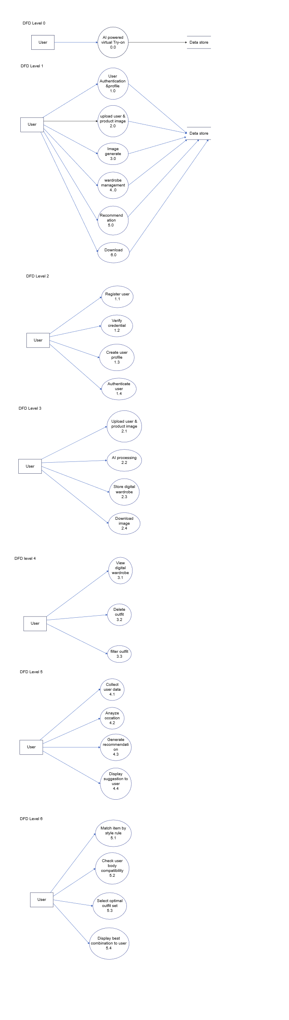
3.5.2 Use case diagram
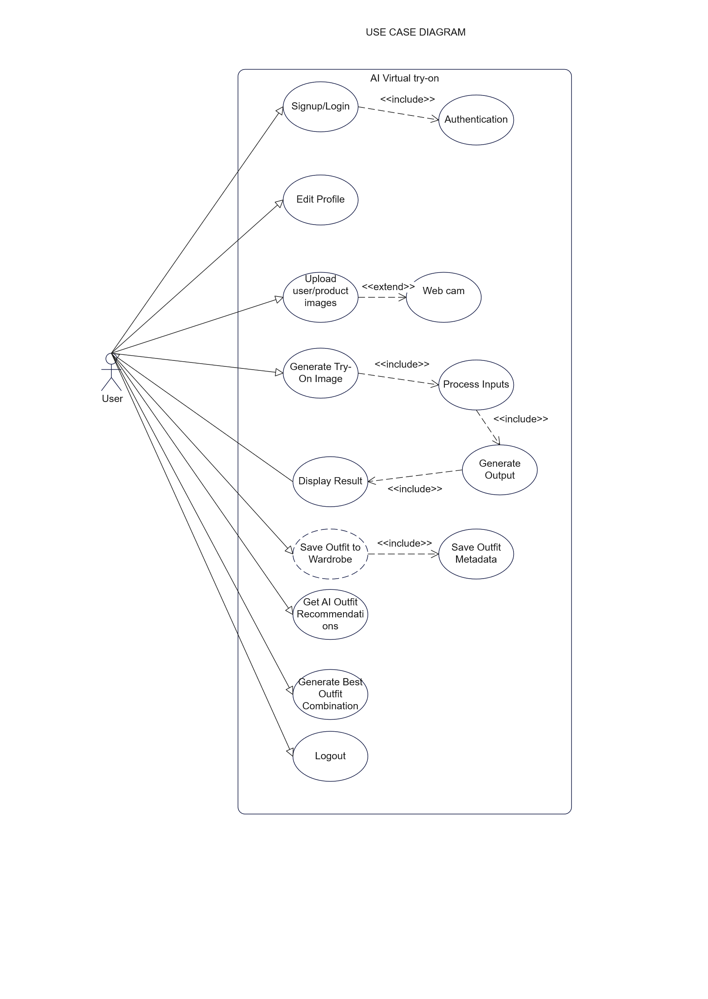
3.5.3 Activity diagram

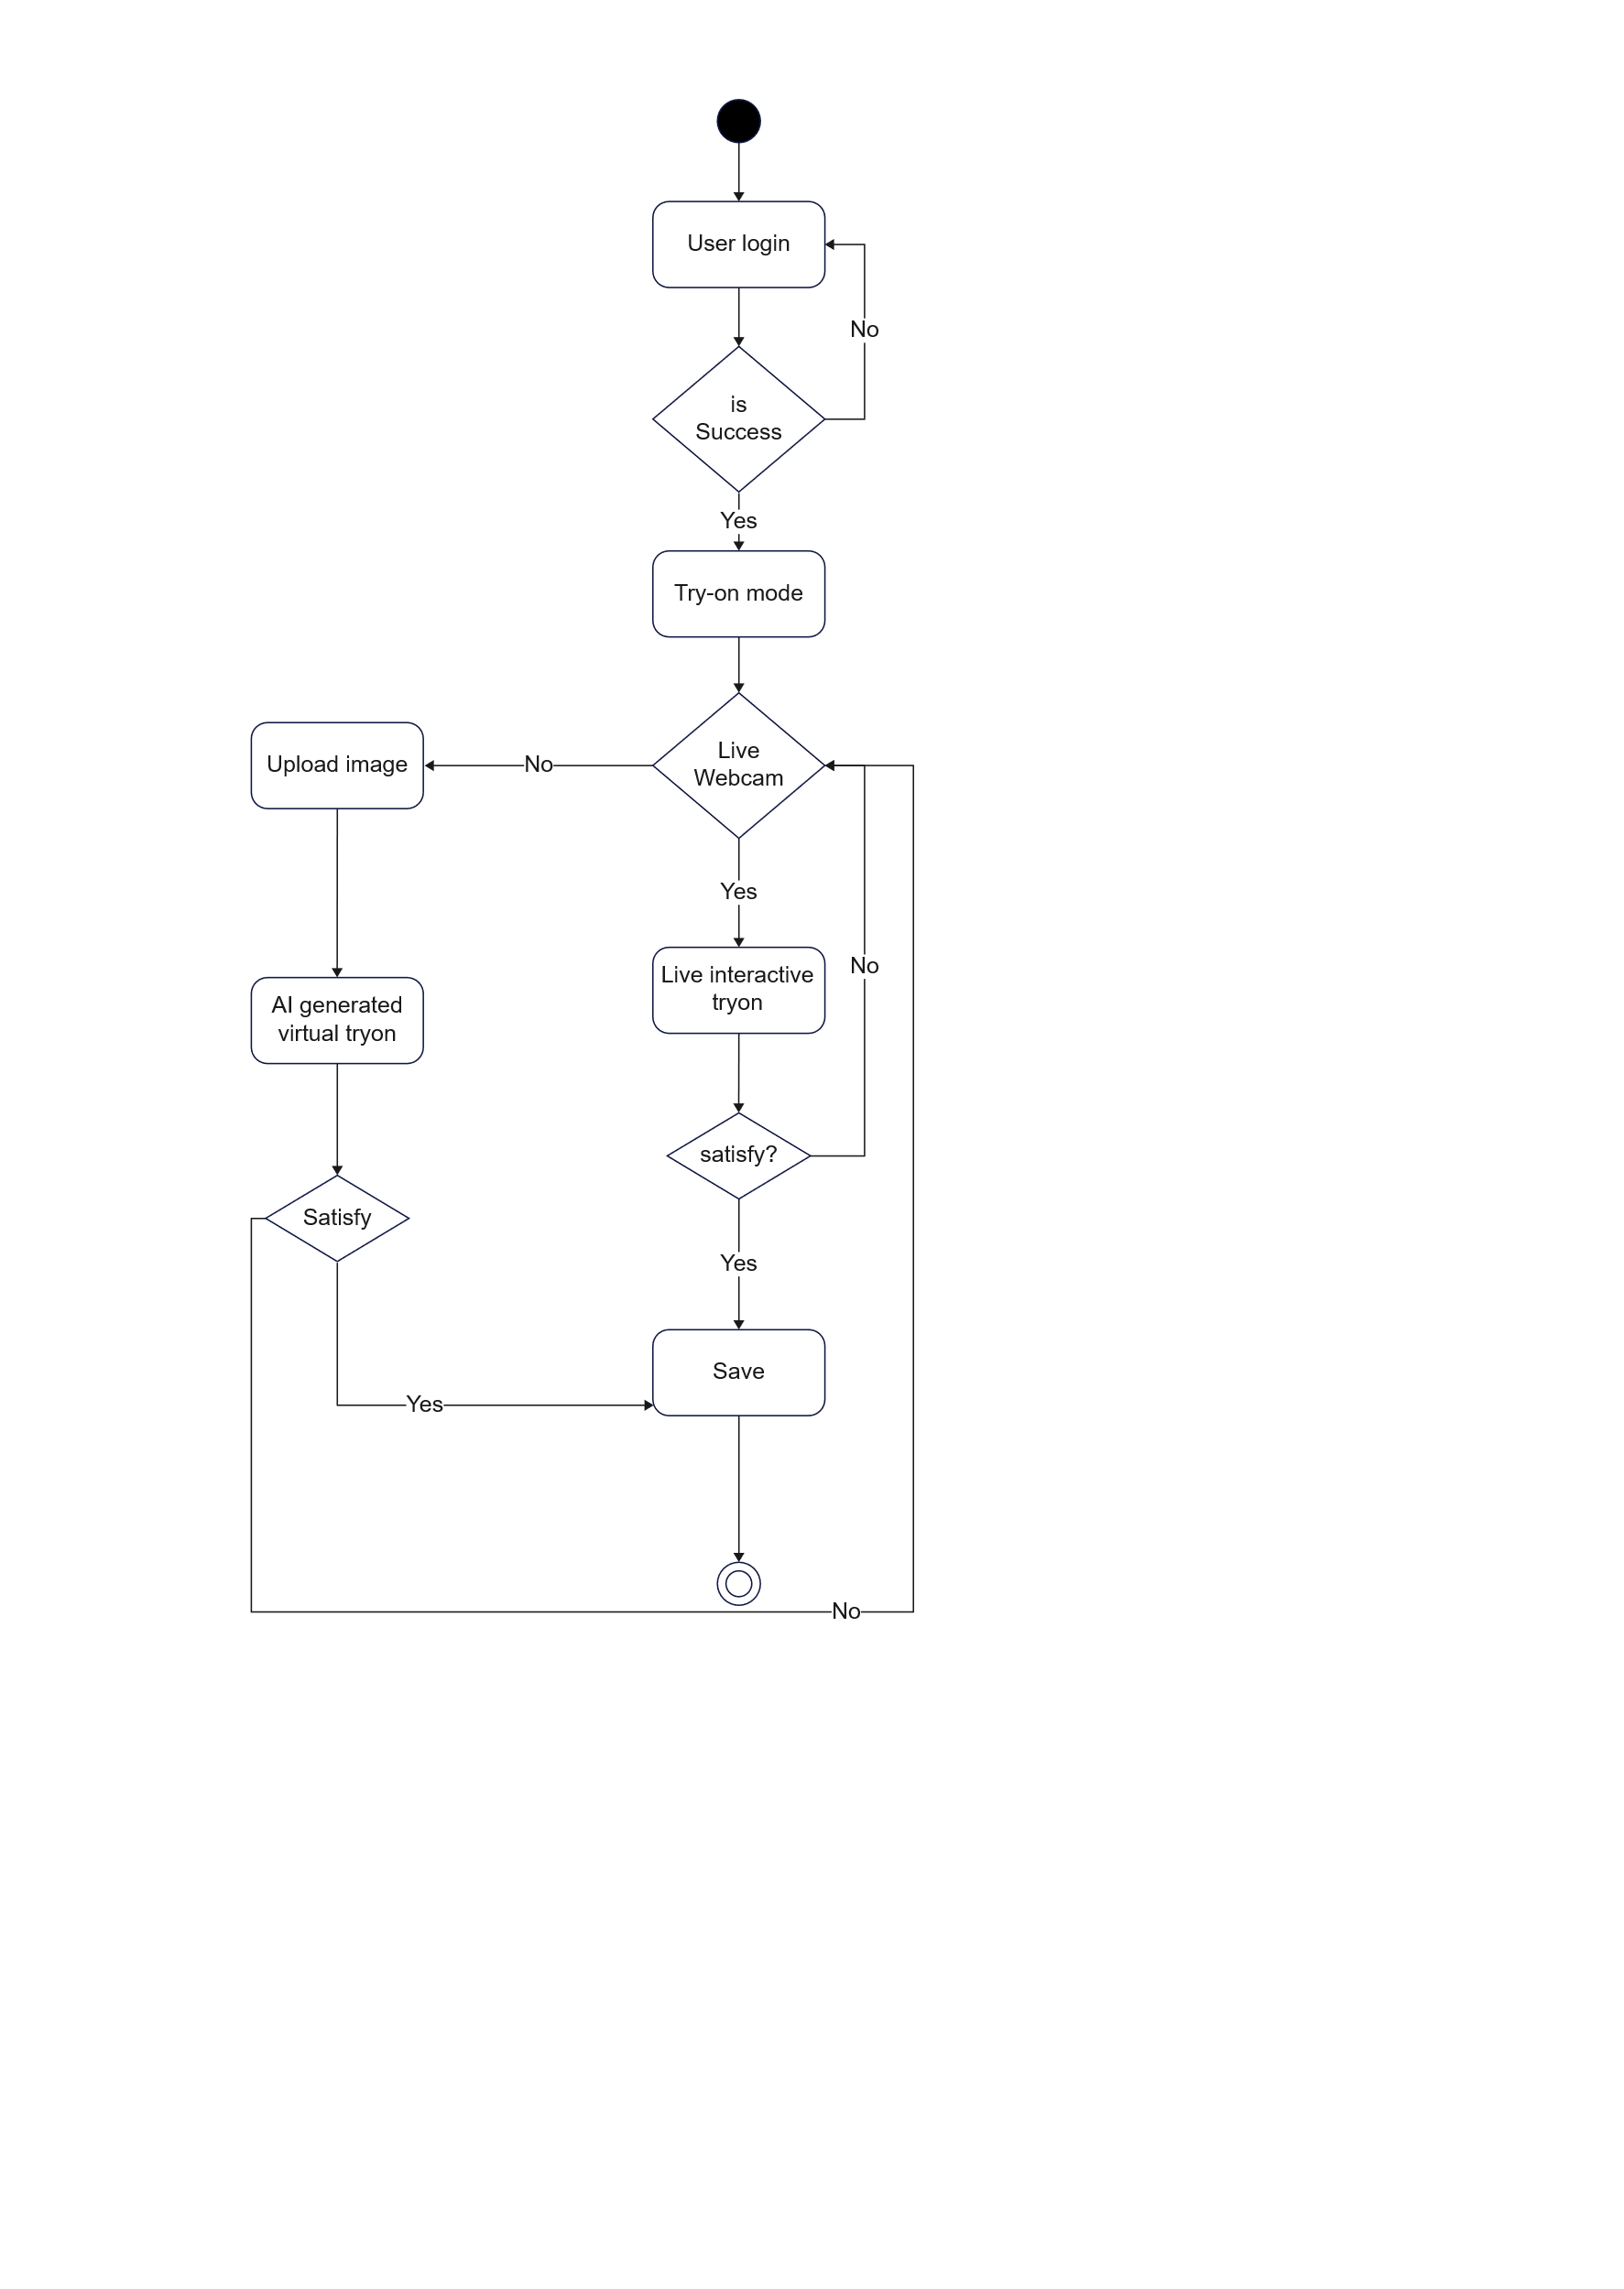
3.5.4 Sequence diagram
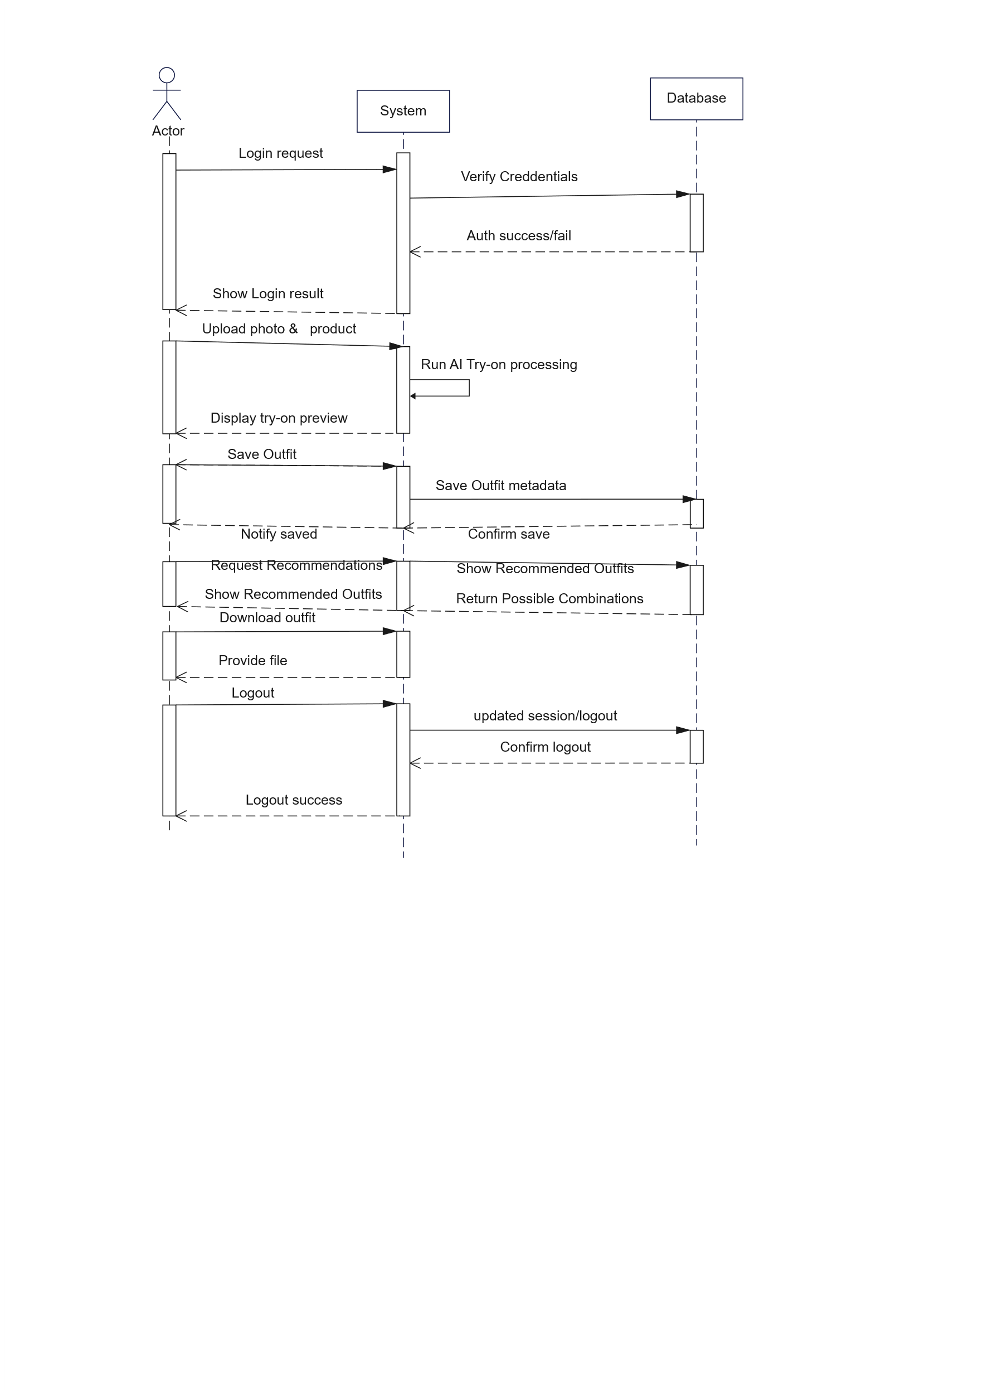

3.5.5 ER Diagram

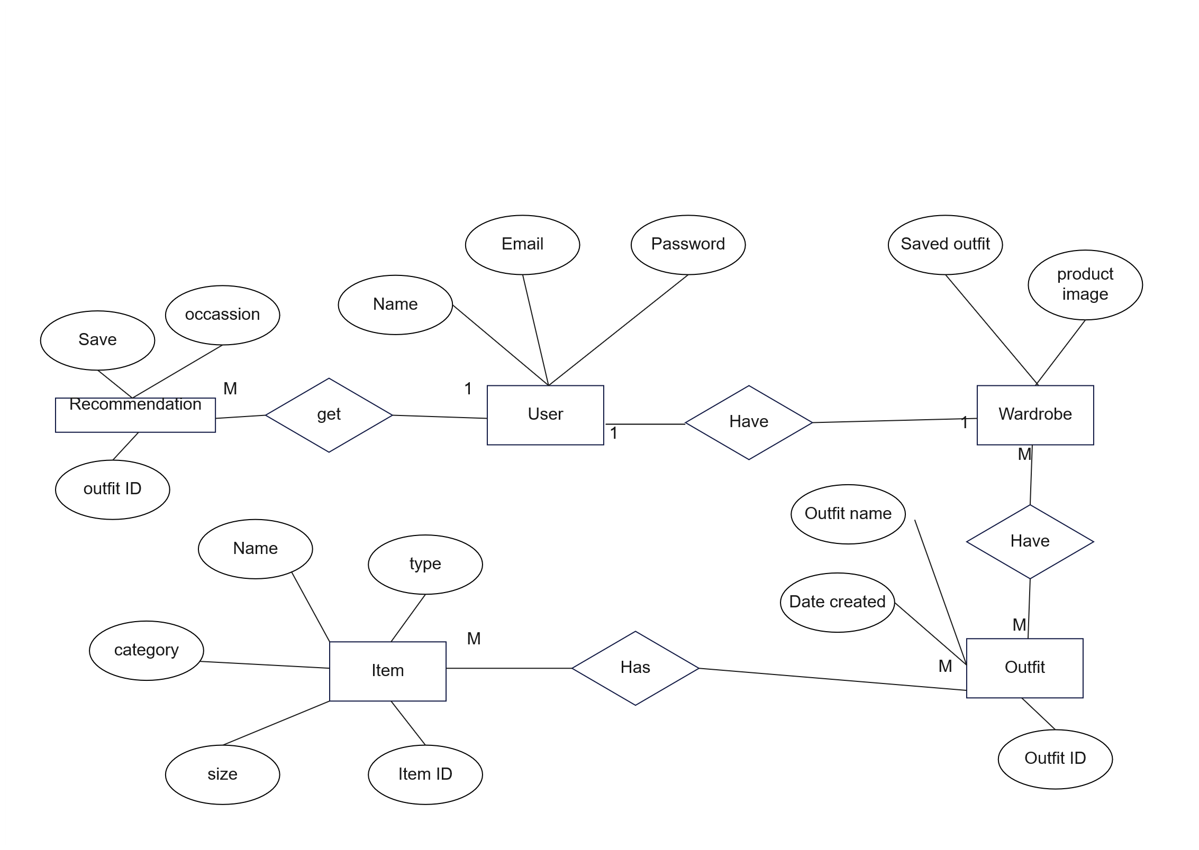
\

3.6 Event Table
Event | Trigger | Source (Actor) | Response by System | Destination (Output)
User Signup | User enters details and submits registration form | User | Validate input, create account, store in database | Confirmation message, User profile created
User Login | User provides email & password | User | Verify credentials, start session | User redirected to dashboard
Upload Photo | User uploads personal photo or captures from webcam | User | Validate image format & size, preprocess image | Image stored temporarily, ready for try-on
Upload Product | User selects or uploads product images (shirt, pants, jacket, etc.) | User | Validate product image, preprocess for alignment | Product added to try-on workspace
Select Try-On Mode | User chooses single item / multiple items / AI recommendation | User | System configures AI pipeline | Next step in process initiated
Generate Try-On Image | User confirms "Generate" | User | AI model processes user photo + products → generate realistic try-on | Output try-on image preview
Save Outfit | User clicks save option | User | Save generated image + metadata (userId, timestamp, product IDs) in Firebase/DB | Outfit added to user’s wardrobe
Download Image | User clicks download | User | Generate downloadable file of try-on image | File downloaded to user device
Get AI Recommendation | User requests outfit suggestions | User | AI analyzes body type, preferences, product library → generate outfit suggestions | Display recommended outfits to use
Logout | User clicks logout | User | End session, clear authentication | User returned to login page
3.6 Event table

Chapter– 4 : System Design

4.1 Basic Modules of Features (Divided by People Categories)
- User Side (End-User):
  - Signup / Login
  - Upload Photo (camera or gallery)
  - Upload Clothing & Accessories (shirt, pant, jacket, glasses, shoes, etc.)
  - Choose Try-On Mode (Single Item, Full Outfit, AI Recommendation)
  - Preview Generated Image
  - Save Outfit to Wardrobe
  - Download Outfit Image
  - Logout
- System Side (Backend + AI Engine):
  - User Authentication
  - Image Validation & Preprocessing (resizing, alignment, background removal)
  - AI Model Execution (realistic try-on image generation)
  - Outfit Recommendation Engine
  - Wardrobe Database Management (storage & retrieval)
- Admin Side:
  - Manage Product Database (add, update, delete clothing/accessories)
  - Monitor System Usage
  - Maintain AI Model Updates
  - Handle User Feedback

  - Data Design

Schema Design
Table: Users
Column Name | Datatype | Size | Constraint
user_id | INT | 11 | PK, AUTO_INCREMENT
full_name | VARCHAR | 100 | NOT NULL
email | VARCHAR | 100 | UNIQUE, NOT NULL
password | VARCHAR | 255 | NOT NULL
created_at | DATETIME | - | DEFAULT CURRENT_TIMESTAMP

Table: Products
Column Name | Datatype | Size | Constraint
product_id | INT | 11 | PK, AUTO_INCREMENT
product_name | VARCHAR | 100 | NOT NULL
category | VARCHAR | 50 | NOT NULL
image_url | VARCHAR | 255 | NOT NULL
price | DECIMAL | 10,2 | NOT NULL
created_at | DATETIME | - | DEFAULT CURRENT_TIMESTAMP

Table: Outfits
Column Name | Datatype | Size | Constraint
outfit_id | INT | 11 | PK, AUTO_INCREMENT
user_id | INT | 11 | FK  Users(user_id)
outfit_image | VARCHAR | 255 | NOT NULL
style_tag | VARCHAR | 100 | NULL
created_at | DATETIME | - | DEFAULT CURRENT_TIMESTAMP

    - Data Integrity

Table Name | Primary Key | Foreign Key(s)
Users | user_id | -
Products | product_id | -
Outfits | outfit_id | user_id  Users(user_id)
Outfit_Products | mapping_id | outfit_id  Outfits(outfit_id), product_id  Products(product_id)
Recommendations | rec_id | user_id  Users(user_id)

Procedure Design
Step 1: User logs into the system.
Step 2: User uploads a photo or opens webcam. Step 3: User selects one or more products.
Step 4: System validates inputs and processes images. Step 5: AI model generates realistic try-on output.
Step 6: User previews, saves, or downloads the outfit. Step 7: Saved outfits are stored in wardrobe.
Step 8: AI Recommendation module suggests outfits.

Flow Chart
[Flowchart Diagram Placeholder]

Algorithm Design
- If-Else logic for authentication, input validation, and model output.
- Loop logic for processing multiple selected products.

User Interface Design
- Signup Page
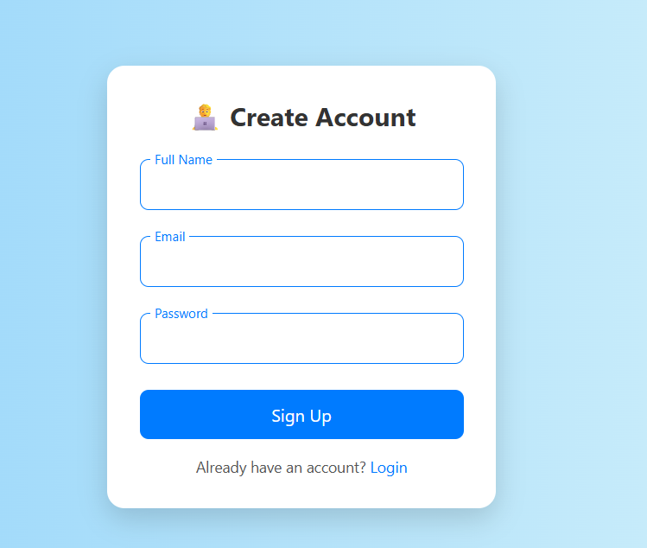

- Login
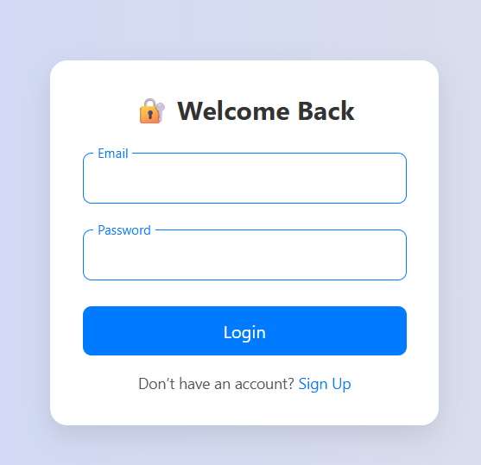
- Home Page
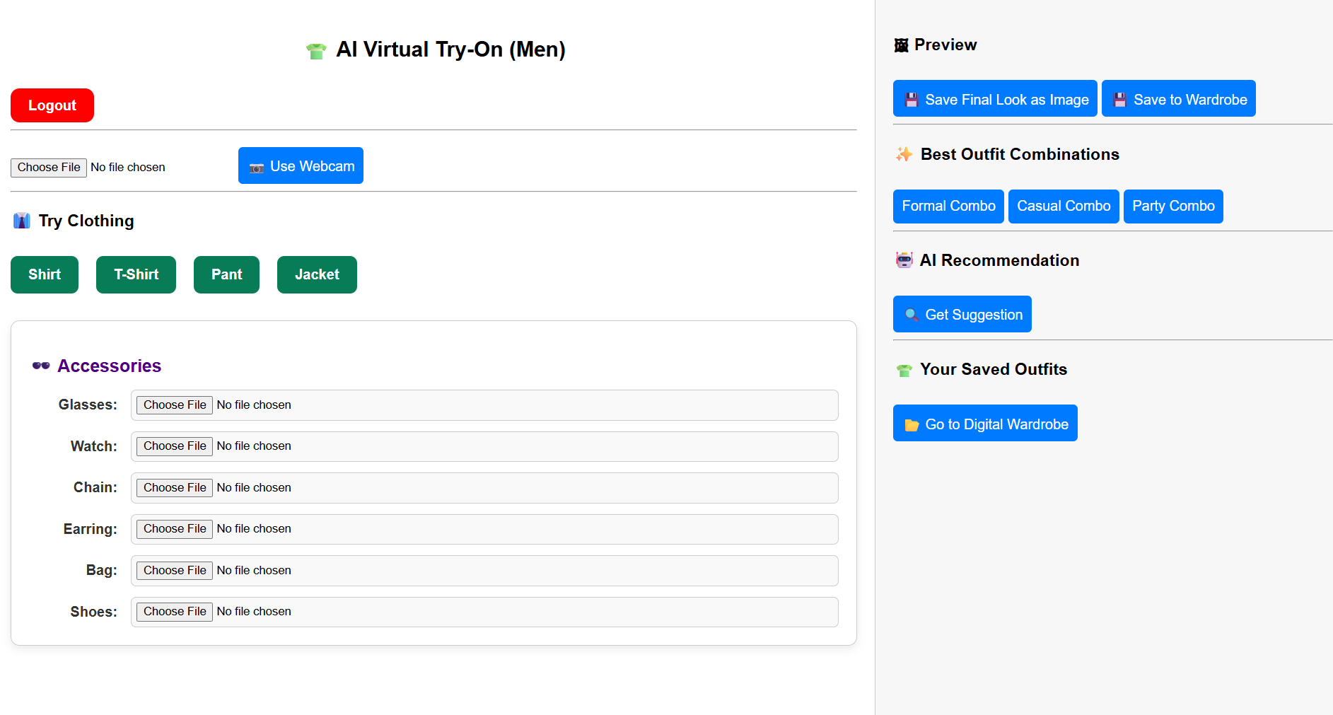
- Wardrobe Page
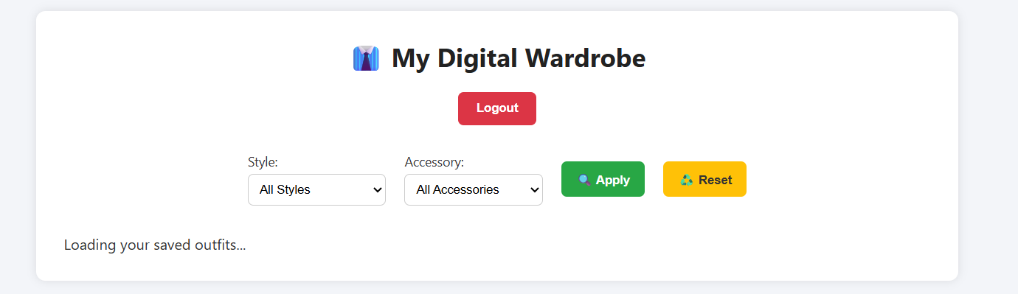

  - Test Case Design

Test Case ID | Module | Description | Input | Expected Result
TC01 | User Module | Login with valid credentials | Email + Password | User logged in
TC02 | User Module | Login with invalid credentials | Wrong Email/Pass | Error message
TC03 | Try-On Module | Upload valid image | User photo + product | Try-on generated
TC04 | Try-On Module | Upload invalid file | Unsupported file type | Error returned
TC05 | Wardrobe Module | Save outfit | Generated outfit image | Outfit stored in DB
TC06 | Recommendation | Generate suggestion | User ID | Outfit list displayed

